 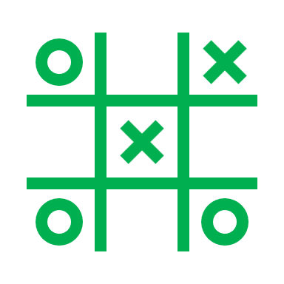 

Game Design Document

for a VR Escape Room

Your Heart, Your Reality

**Launch Date**

**Ariq**

**Confidential Disclaimer**

This Game Design Document has been prepared for review by Ariq. All information is confidential and proprietary and should not be shared without written permission.

**Overview of the Game**

Your Heart, Your Reality is a puzzle game that depicts the true feelings of one who has seemingly rejected the real world and views it differently. Inspired by puzzle games such as Portal (2007), this game is intended to be a puzzle-solving and innovative experience, with many different approaches and thinking processes.

In Your Heart, Your Reality, you find yourself awoken to a mysterious room filled with eerie yet familiar sights. These sights are what your human heart truly feels about life, the world and reality. As you stay in the room, you have a strong desire to reject this supposedly true feeling of yours and thus do everything possible to escape, solving puzzles that reveal answers and advancing forward, to more rooms. The path of escape lies in the final room.

Inspirational art:

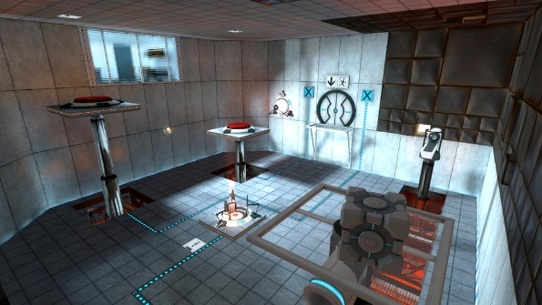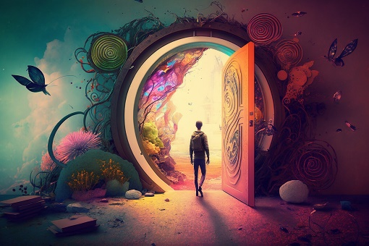

**Unique Selling Points**

Relatable and Compelling story: A scenario you can relate to, as the world is not always pleasing. Multiple puzzles that depict certain ways of life.

Visuals: A spooky and eerie environment, with messages that have strong meaning behind them, a dark atmosphere to represent the negative side of the world.

Movement: Teleporting as an easy and effective way of movement.

Object Interactions: Pick up, use and throw objects to your liking.

Hidden Details: Strong messages and meanings behind the appearance of everything, allowing many different interpretations of the possible feelings.

Challenging puzzles: Puzzles that require a level of problem-solving skills and intuition, knowing what solutions are possible and finding new solutions each time.

Extra challenges possible: It is possible for the player to set their own restrictions in order to have an even harder challenge (such as time limit).

**Game loop**

The game starts off with the player spawning the room.

The player would then move around the room, viewing various objects found in it. This is done with a teleportation feature, where the user only needs to point and click to a certain part of the floor to instantly move there. Only the ground can be used as teleport points.

The player would then attempt to figure out how to solve the puzzle in the room.

After solving the puzzle, the way to the staircase would open, leading to the next room.

There are a total of four different rooms, each with different premises and appearance. They follow a similar process but get progressively more difficult and require more critical thinking.

The first puzzle involves figuring out a 4-digit code to enter on to a numpad. The numbers are scattered discreetly, in a way that it is not clear. For example:

In the darkest hour, hate reigns supreme,

A vile heart, with no hope, no gleam.

**Three** shadows cast, **two** whispers scream,

**One** lies repeated, **four** souls redeem.

Each line would be separated and scattered across the room.

The second puzzle involves creating an object that resembles ‘destruction’. In the room, there are objects scattered and the appropriate objects to find would be three items that together could look like a bomb. The three items would be a black bowling ball, a thick string and a lighter. These objects need to be placed side by side on a marked table near the door. Only then can the door open. The items that need to be gathered will be rather unclear and there will be other objects as distraction. To find out that a bomb is the intended object, there will be a few hidden messages that implies explosion.

The third puzzle involves combining pieces of a shattered mirror, with each shard showing a letter. Arrange the shards to make the words ‘World End”. Only then will the door to the next room open.

The fourth puzzle involves a memory test, where 4 buttons of 4 colours need to be clicked in the right order. The order is red, blue, green, white, red, white, red, green, red. This combination can be found around the room where objects of a certain colour can be found, with a number written on them which is their position in the order sequence. For example, a red toy car with the number 1 on the hood.

At the final room, the puzzle solved would open to a final doorway which would be the end of the game, and the story.

**Gameplay Scope**

Each level would take roughly 10 to 30 mins to complete (It depends on how quickly the player can solve the puzzle). The whole game is set to be around 2 hour long.

There are a total of 4 levels.

The average playtime would be 2 hours.

The objectives would be to escape the chamber that the player is trapped in to destroy and reject those implied feelings of the heart.

Play as the role of person who has a distorted feeling of the world.

**Art Style**

The art style is set to be mainly consisting of low-poly designs. This is because the game is not set to be very realistic and instead aimed to be more optimized for all users. The setting would consist of just four rooms and the outside does not get to be seen and hence need not be generated. Each of the rooms are different in terms of appearance and will convey a different kind of human feeling each time. There is only one character which is the player itself as it is a singleplayer game. The UI is set to be simple and straight forward to minimize clutter and potential confusion. The menus will not take up too much space on the user’s visibility.

**Player Profiles Stories**

Kevin enjoys puzzle-solving games and is always interested in accomplishing them in a fast manner as to challenge his quick thinking. He will approach the game in a manner where he is always looking for clues and possible answers to the puzzle. He would enjoy the game as these puzzles are not that easy and require quite a strong thinking process to figure them out quickly. This will fill that adrenaline rush and pressure of solving puzzles quickly that Kevin enjoys a lot.

Janice enjoys puzzle-games that give off a certain story and hidden meanings behind their designs and appearance. She would approach the game slowly and take her time to view her surroundings and analyze what meaning a certain area conveys or give her own possible theories and opinions. As the game is filled with a lot of messages and meaningful objects, this game would allow her to experience what she enjoys.

As such, these two players would approach the game very differently. One would try to complete the game as quickly as possible, almost as if they are a speedrunner, while the other would be very slow and meticulous, taking in all the information and understanding deeper about the environment, messages and story.

**Milestone Schedule**

Milestone 1: Planning and confirming game concept ideas.

* Brainstorm all game ideas including each level’s content
* Confirm core gameplay mechanics
* Draft concept art of game UI, scene, etc.

Milestone 2: Gather appropriate game assets and build a standard scene.

* Download and create Unity assets
* Build the actual rooms, with appropriate colours, lighting, measurement and dimensions
* Add various content into the rooms
* Ensure that the rooms and its contents can be visibly seen for interaction

Milestone 3: Add core gameplay functionalities

* Ensure that the game is set to be in Virtual Reality.
* Set the correct controls, using the VR hand-controllers.

Milestone 4: Implement game interactions

* Ensure that interaction of objects, puzzles and movement of the player works properly and as intended
* Check that all these functions work as planned

Milestone 5: First Testing and prototype

* Test the game as a whole
* Try out many different possible game interactions
* Note down observations, bugs, room for improvement

Milestone 6: Bug-Fixing and improving game

* Follow the nots made and make changes to the game, fixing problems, cleaning up the game area and make it look nicer.
* Improve game detailing and fit the intended environment

Milestone 7: Second testing and prototype

* Like Milestone 5, test out the improved game again
* Make more notes of the gameplay, looks, etc.

Milestone 8: Feedback and more fixing

* Seek feedback from others by letting them test out the game as well
* Note down each comment made and what they recommend for improvement or other possibilities
* Do this for as many people as possible
* Make amendments and improvements according to the feedback
* Completely furnish the game and give more details
* Finalize the game’s look and ensure that it meets to standards.

Milestone 9: Final Testing

* Ensure that the whole game works properly with little to no problems
* Ensure that the game meets high satisfaction levels.
* Make sure that it is fully complete with all intended features
* If it still has some problems, repeat the previous two milestones
* Finalize game.

Milestone 10: Game has been completed

* Present the game and prepare for publishing.